Earth Science Regents Basic Review Guide

Definitions:

Relationship: as one measured quantity increases/decreases, the other measured quantity increases/decreases in response.

Density: material’s mass divided by its volume; (how much “stuff” is in a certain space)

Relative Humidity: how much water vapor is in the air compared to how much water vapor could be present in the air

Dew Point: the temperature to which the air must be cooled to reach water vapor saturation (no more water vapor can be added); where relative humidity is 100%: even though this value is a temperature, it can only be changed by adding or subtracting water vapor

Transpiration: release of water vapor into the air by plants

Evapotranspiration: evaporation and transpiration combined

Insolation: incoming solar radiation (sunlight)

“Duration of Insolation”: length of daylight (how long the sun shines); greatest on June 21 and shortest on December 21

Angle of Insolation: height of sun measured in degrees; highest in summer and at noon; lowest in winter and at sunrise/sunset

Gradient: slope or steepness of change (think steepness of a hill). change in some value over distance.

Rate: how fast something happens/moves (think “speed”); change in some value over time.

Condensation: change from water vapor into liquid water (how clouds, dew and fog form)

Revolution: orbiting around another celestial body (Earth revolves around the sun)

Rotation: spinning on its axis (Earth rotates one time around in about 24 hours)

Basics:

A substance always has the same density, no matter how much you have of it. (Cut something in half; density is still the same.)

Air pressure is higher at lower altitudes because air density is greater
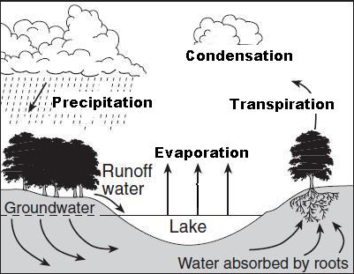
Most changes are cyclic, i.e., water cycle, rock cycle, convection cycle, etc.

Changes are also predictable, i.e., seasons, tides, moon phases, etc.

For most materials, as temperature increases, density decreases. (Air expands when you heat it.)

Exception: Water expands (becomes less dense) as it freezes. (That’s why ice floats.)

Water is most dense near 4ºC, when it is still a liquid.

Everything in nature moves from high to low (except for warm air).

Relationship Graphs:

As one value increases, the other value increases.
As one value increases, the other value decreases.

Astronomy:

The best model of Earth is an oblate spheroid (because of Earth’s rotation), but appears round and smooth.

The universe began with a big explosion called “The Big Bang”. Evidence includes universe expanding and background, microwave radiation.

Universe is about 14 billion years old. Solar system, sun and Earth are only 4.6 billion years old.

The moon is the most important influence on Earth’s tides (the sun is secondary).

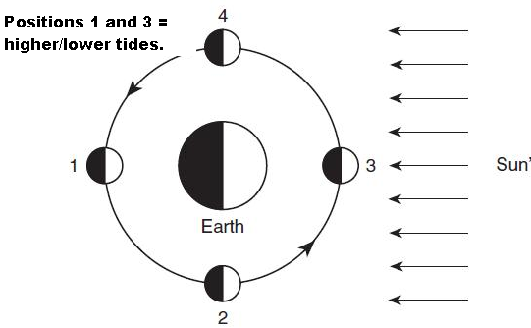
High tide bulges are generally under and opposite the moon.

Spring tides (higher high and lower low tides than normal) occur at full and new moon phases.

Solar eclipses occur at new moon phase (Position 3 on the diagram.). Lunar eclipses occur at full moon phase (Position 1 on the diagram).
Jovian (Jupiter-like) planets are large and made mostly of low density gas. Terrestrial planets (Earth-like) are smaller, high-density rocky/metallic spheres.

Nuclear fusion of hydrogen atoms into helium is the source for the sun’s energy.

Our solar system is located on one of the outer arms of the Milky Way galaxy.

Most celestial objects appear to rise in the east and set in the west because Earth rotates on its axis from west to east (not Polaris and the circumpolar stars).

Earth rotates at a rate of about 15 degrees per hour (360 degrees / 24 hours = 15 degrees/hour)

Earth revolves around the sun one time (called its period) in 365 ¼ days (one year).

We see different constellations during different seasons because of Earth’s revolution around the sun which causes our night-time line of sight to change.

All planetary orbits are elliptical, so planets continuously change their distance from the sun.
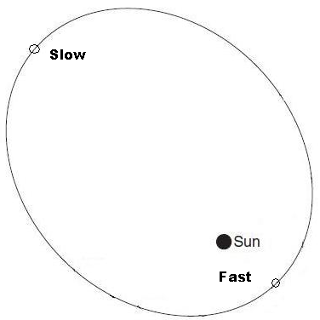
Gravity changes with distance.
Greater distance = lower gravitational attraction.

The closer a planet is to the sun, the higher its orbital velocity.

Planets like Mars, Jupiter and Saturn appear to go backwards (retrograde) against the stars as Earth passes them in space.

The higher a celestial object’s eccentricity, the more out-of-round/oval (“flatter”) is its orbit.

The universe is expanding and has been since the “Big Bang”.

Red Shift: indicates stars/galaxies moving away from the observer.

Blue Shift: indicates stars/galaxies moving toward the observer.

Remember the “Beamer Rule”:
Blue headlights – coming towards you.
Red taillights – moving away from you

We always see the same side of the moon because the moon’s rotation period is the same as its revolution period around Earth (27 1/3 days).

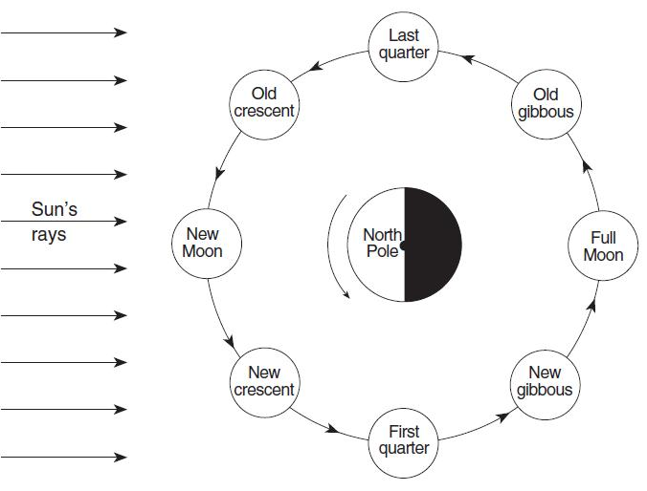
The moon shows phases because it revolves around Earth (half of moon is always lit though).

It takes 29 ½ days for the moon to go through one full cycle of phases (full moon to full moon).

Maps:

Contour lines point upstream/uphill (lines form a v-shape).

Latitude lines are drawn east-west, but measure distances north and south of the equator.
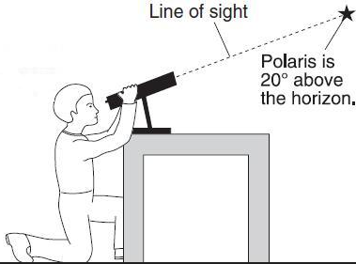
(Remember: latitude=flatitude)

Longitude lines are drawn north-south, but measure distances east or west of the Prime Meridian.

The altitude of Polaris is the same as your latitude. (The observer’s latitude is 20ºN.)

The closer isolines are together, the steeper the slope or gradient. (The tighter the isobars, the faster the winds.)

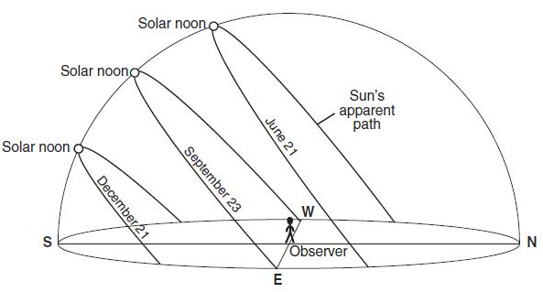
Climate:
23.5º
23.5º

Summer solstice: June 21st; longest
daylight (duration of insolation) of the
year; our highest noontime sun.

Winter solstice: December 21st; shortest
daylight of the year, lowest noontime sun.

Equinoxes are March 21st and September
23rd; 12 hours of daylight everywhere
on Earth.

The sun’s vertical rays shift 23.5º from season to season because of Earth’s tilt. (total of 47º from summer to winter)

Only the Equator has 12 hours daylight every day of year.

Hottest part of year is in July even though longest day of year is June 21st because northern hemisphere is still gaining more heat during the day than it is losing at night.

Hottest part of day is about 2:00 pm even though sun is highest at noon because Earth is still gaining more heat than it is losing.

Increase in latitude and altitude both have the same effect on climate (make it cooler).

Water takes longer than land to heat up/cool off because water has a higher specific heat/”heat capacity”.

Water bodies moderate temperature (smaller temperature range) so cities near large bodies of water have milder summers and winters.

Vertical (overhead) rays of the sun can only strike Earth between 23.5ºN and 23.5ºS latitude (Tropics of Cancer and Capricorn). (Not in NY!)

The lower the altitude of the sun, the longer the shadow cast by an object. So, shadows are shortest in the summer and at noon; shortest in winter and at sunrise/sunset.

A shadow is always opposite the sun (north side at noon).

Foucault’s pendulum and the Coriolis Effect are proof that Earth rotates.

Earth is closest to the sun in January (NOT a reason for hot summers).

Summers are hottest because the sun’s angle of insolation and duration of insolation are greatest.

Black, rough and dull surfaces are the best absorbers of heat.

Good absorbers of heat are also good radiators of heat.

Most energy absorbed by Earth is short-wave visible light. It is radiated at night as longer-wave infrared (IR) energy.

Carbon dioxide (CO2) is a major greenhouse gas produced by burning fossil fuels. Methane and water vapor are also important greenhouse gases.

Know this chart for NY at 42ºN latitude.

Approximate Date | Latitude of Sun’s Direct Rays | Direction of Sunset and Sunrise | Altitude of Noon Sun | Approximate Length of Daylight
September 23 (Autumnal Equinox) | Equator (0º) | Rises due East Sets due West | 48º | 12 hours
December 21 (Winter Solstice) | Tropic of Capricorn (23.5ºS) | Rises in SE  Sets in SW | 24.5º (lowest) | 8 hours (shortest day)
March 21 (Vernal Equinox) | Equator (0º) | Rises due East Sets due West | 48º | 12 hours
June 21  (Summer Solstice) | Tropic of Cancer (23.5ºN) | Rises in NE  Sets in NW | 71.5º (highest) | 16 hours (longest day)
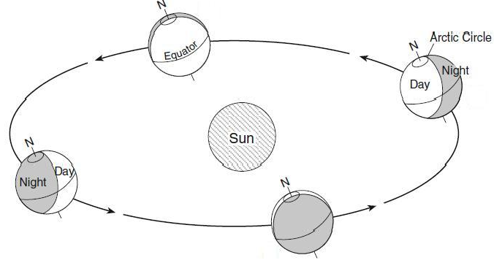

The North Pole tilts towards the sun in the summer and away in the winter.

The southern hemisphere has winter when we have summer, and vice versa.

Plate Tectonics:

Ocean crust is thin, made of basalt and is more dense than continental crust.

Continental crust is thick, made of granite and less dense than oceanic crust.

Mountains form by continental plates colliding or from volcanic action at divergent or convergent boundaries.

Subduction of ocean crust occurs at convergent plates because ocean crust is more dense than continental crust.

Divergent boundary: plates spreading; mid-ocean ridge or rift valley; volcanoes and shallow earthquakes.

Convergent boundary: plates coming together; subduction zones and trenches, volcanoes and deep earthquakes

Transform boundary: plates sliding by each other; (San Andreas Fault), earthquakes only
P waves move faster than S waves.

S waves do not go through liquids; P waves go through solids and liquids. (That is how we know that Earth’s outer core is liquid.)

You need three seismometer readings to plot an earthquake epicenter.

Tectonic plates move because of convection in the Asthenosphere (mantle).

Weathering and Erosion:

Chemical weathering (think rust) occurs most rapidly and dominates in warm, humid climates.

Physical weathering dominates in cold (but not always frozen), humid climates (think frost-wedging).

Porosity does not depend on particle size (small particles have same porosity as large).

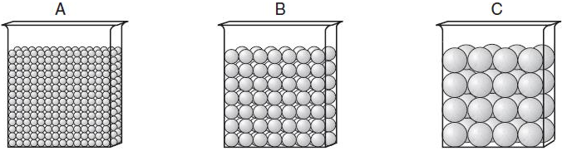
As particle size increases, permeability increases (gravel is more permeable than sand or silt).

As particle size decreases, capillarity increases.

Streams are the number one agent of erosion.

Stream velocity depends on slope (gradient) and discharge (water volume).

Velocity is greatest (and most erosion occurs) on the outside of stream meanders.

Velocity is lowest (and most deposition occurs) on the inside of stream meanders.

Heavy, round and dense particles settle out fastest/first as a stream slows down.

Graded bedding (vertical sorting); biggest particles are found on the bottom.

River and wind erosion sediments are rounded. Glacier and mass movement sediments are not.

Glacial sediments are unsorted. (Wind, stream and ocean agents sort sediments.)

Glaciers form U-shaped valleys including the Finger Lakes. (Rivers carve v-shaped valleys.)

Long Island formed of glacial terminal moraines.

Arid landscapes have steep slopes with sharp angles (think Grand Canyon).
Humid landscapes have smooth, rounded slopes (think about where you live).

Weathering rate increases when a substance is broken into pieces and surface area increases.

Meteorology:

Air moves clockwise and outward from a high. (“High to Low”) (In the northern hemisphere)

Air moves counter-clockwise and into a low (“High to Low”) (In the northern hemisphere)

Remember: “High clock on the wall and low counter”.

As moisture increases, air pressure decreases (“wet” air is less dense/lighter than “dry” air).

Air pressure decreases with altitude; temperature does too!

Highs are cool and dry; lows are warm and wet. Remember: “High and Dry”.

Wind blows from high to low pressure.

Wind is named for the direction it is coming from … the direction you are facing when facing into the wind.

The closer the air temperature is to the dew point, the greater the chance for precipitation.

The closer the air temperature is to the dew point, the higher the relative humidity.

Know this Process: Air is warmed, becomes less dense due to expansion; is forced upwards; expands and cools as it rises; temperature falls to the dew point; condensation of clouds occurs.

Windward side of a mountain has a wet, cool climate; leeward (downwind) side has a hot, dry climate (desert)

Condensation requires some particle (condensation nucleus) to occur.

The air masses that mainly affect our weather are mT (warm and moist from Gulf of Mexico) and cP (cool and dry from Canada).

Weather moves from southwest to northeast in the eastern United States (including NY).

Cold fronts usually move the fastest.

To convert station symbol air pressure in millibars:
If number is less than 500, put a “10” in front and a decimal point to the left of the last digit.
If number is greater than 500, put a “9” in front & a decimal point to the left of the last digit.

Geologic History

Index fossils are good time markers because they lived for a short time, but over a large area.

Volcanic ash is a good time marker for the same reasons.

The bottom rock layer is the oldest.

Intrusions and faults are younger than the rock they cut across (the rocks gotta be there first to be disturbed).

An unconformity (missing rock) indicates erosion.

One half of a radioactive element decays each half-life. (Percentages of remaining radioactive elements: 1 HL = 50%, 2 HL = 25%, 3 HL = 12.5%, 4 HL = 6.25%, 5 HL = 3.125%, etc.)

To determine the age of a substance, multiply number of half-live times the years in one half-life.

Use U-238 to date very old objects. (half-life of 4.5 billion years).

Use C-14 to date more recent objects (like human remains). (half-life of 5,700 years).

Rocks and Minerals

Sedimentary rocks (compaction and cementation) are most likely to have fossils.

Igneous rocks (cooling and solidification) have large crystals from slow cooling (intrusive) and small crystals from fast cooling (extrusive).

Metamorphic rocks (heat and pressure) can show foliation (banding) and distortion.

Properties of minerals are determined by, “the internal arrangement of their atoms” and their composition.

Calcite fizzes in acid (so do limestone and marble).

Test Taking Strategies

On every test question, ask yourself, “Can the Reference Tables help me to answer this?”

Use the front cover of the ESRT for equations/formulas.

If the question has to do with time or living organisms, look at pages 8 and 9 on the ESRT.

If you don’t know the right answer, first try to eliminate wrong answers and then guess from the remainder.

Answer every question; don’t leave any blanks.

If you have to, skip over questions that have you stumped. Mark them and come back to them later. Other questions in the test may give you clues to the question that is stumping you.

If certain words are confusing you, cross them out and substitute a different word. Then, re-read the question to see if it is now clearer.

Don’t skip reading the directions. They may help you answer questions.

Study diagrams and try to understand what is going on before looking at the questions.

Use underlining, highlighters, whatever you want to help you. Remember though, the answers have to be on the correct answer sheet.

Be sure to read all possible answers before deciding on your answer. Sometimes a later answer is better. (Example: Answer #2 could be a good answer, but answer #4 might be better.)

Once you have completed the test, check over your answers, but only change an answer if you know your first one was wrong. Normally, your first answer is the correct one.

The Earth Science Reference Tables are your best friend. Use them! Use them! Use them!

Relax; you are more than ready to do well on this test.

