Answer Key for 2010 ESRT Scavenger Hunt
(handout says “Beth Henderson, Honeoye Falls-Lima Middle School: ESRT scav hunt 1010” on the footer)

1. 4,500,000,000 years
2. Liquid water
3. Evaporating 10 grams of water
4. 21.6 cm
5a. 5 half-lives
5b. It’s organic and existed lived
5c. N₁₄
6a. 1 g/cm³
6b. Ice is less dense than liquid water
7. Eurypterus remipes
8. Hydrogen and oxygen
9. Aluminum
10a. No
10b. K
11. 8.4 Joules
12. 1.1 °C/m
13. Manhattan Prong
14. Champlain Lowlands
15. Plateau
16. Taconic Mountains, Hudson Highland, & Manhattan Prong
17. Appalachian/Alleghany Plateau
18.
 | Rochester | Old Forge
Latitude | 43° 10’ N | 43° 45’ N
Longitude | 77° 35’ W | 75° 00’ W
Bedrock age | Ordovician | Middle Proterozoic
Igneous, Sedimentary or Metamorphic? | Sedimentary | Metamorphic
Direction from Ithaca | NW | NE
Distance from Ithaca, in Kilometers | 125 km | 190 km
19. Gulf Stream current
20. The Peru Current brings cold water from the Antarctic region toward the equator, and therefore, cools the west coast of South America.
21. Southern Ocean current
22. North Equatorial Current
23. 47°
24. continent-continent plate boundary collision between Indian-Australian and Eurasian tectonic plates
25. divergent
26. two: divergent and convergent
27. convergent plate boundaries

28.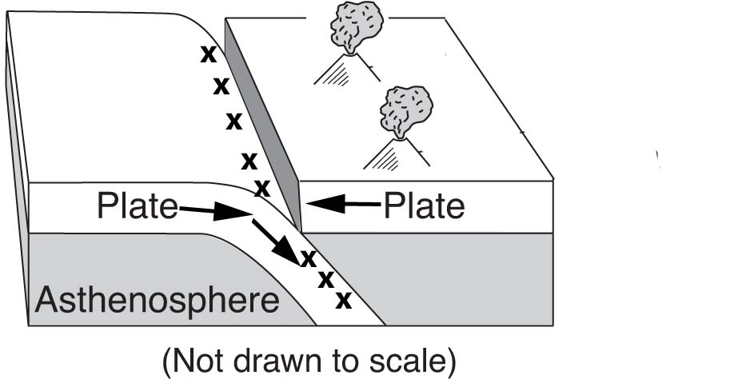

29. San Andreas Fault
30.
 | Convergent | Divergent | Transform | Complex/Uncertain
Relative motion | toward each other | away from each other | sliding past each other
Symbol

Example (give location using two plate names) | Nazca Plate  & South American Plate | North American Plate & Eurasian Plate | North American & Pacific Plate | Eurasian Plate & North American Plate
2 features and/or events that happen at this type of boundary | trenches / volcanic mountains / folded mountains / earthquakes | mid-ocean ridges / rising magma / rift valley / earthquakes | faults / earthquakes

31. weathering & erosion
32. all three types
33. clay, silt, & sand
34. 4 cm/second
35. 0.0004 – 0.006 cm
36. diorite
37. vesicular basalt contains air pockets (vesicles) and basalt does not
38. olivine mineral so iron, magnesium, silicon, oxygen
39.
Rhyolite | Rock Name | Basalt
felsic  low | Composition
low  pos | Density
Potassium feldspar, quartz, plagioclase feldspar, biotite, & amphibole | Minerals Present | Plagioclase feldspar, pyroxene, olivine, amphibole.

40. siltstone
41. sandstone is compacted and cemented fragments, dolostone is crystals from precipitates and evaporites
42. foliated (schist) and non-foliated (marble)
43. no, because there is no pressure involved – just heat.
44. 57,000,000 years
45. coelophysis
46. mass extinction
47. no
48a. sedimentary
48b. 390 – 400 million years old (middle Devonian)
48c. marine
49. marine
50. asthenosphere / plastic mantle
51. pressure = 3 million atmospheres; temperature = 6,200 °C
52. crust & rigid upper mantle
53. 2,500 °C
54. 4,700 km (+/- 100 km)
55a. 7:27:00
55b. 7:32:40
56. 5 °C
57. 70%
58. increases
59.
59. 4 °F
60. 100
61. 992.2
62. 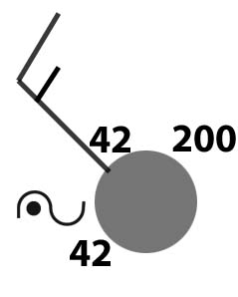
63. warm front
64a. continental polar
64b. cP
65. The temperature decreases from 15°C at sea level to -55°C at 12 km above sea level. Then, the temperature increases to 0°C until it reaches 50 km. Then, from 50 km to 80 km, the temperature decreases to -90°C.
66. water vapor concentration increases
67. the wind belts shift northward
68. southwest
69. wet, low
70. radio waves, infrared, red visible light, blue visible light, x-rays
71. shorter than
72. luminosity and temperature

73.
 | Spica | Aldebaran
Color | blue | Orange/red
Temperature | 25,000 °K | 3,800 °K
Luminosity | 40,000  G | 300
Size | Supergiant | giant
74. pollux
75. as the planet’s distance from the sun increases, its period of revolution increases
76. 386,000 km
77. mars
78. 317.83
79. calcium and oxygen
80. 1. exhibits cubic cleavage
2. metallic
3. hardness of 2.5
81. pyroxene and amphibole
82. limestone is made of calcite (calcium carbonate) which fizzes with acid.

